**User guide**

Double click on Elisa access application to open. It will open to:

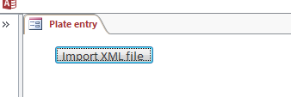

**The default format for import files is assumed to be XML**

This will open a standard file browser (remembers previous folder after first use).

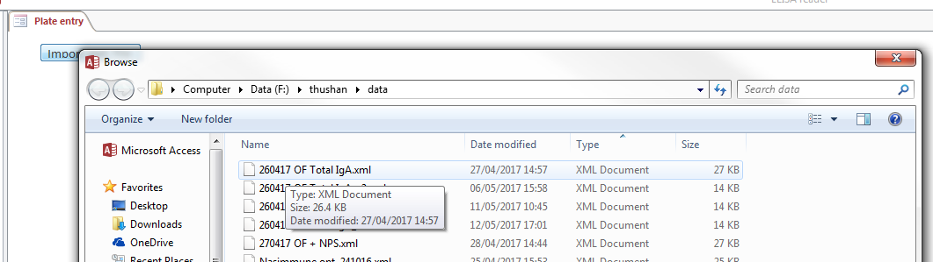

Select the required file – only XML files will appear.

Two possible warning screens may appear:

File and pathname already loaded – **the file and pathname must be unique** – no alternatives

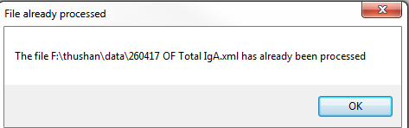

The background wells in E 10 to 12 and F 10 to 12 have negative values

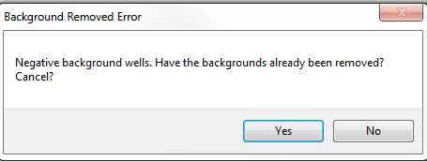

This implies that the backgrounds have already been removed **– the code assumes all data is uncorrected.**

Assuming an appropriate XML file the following fields will appear

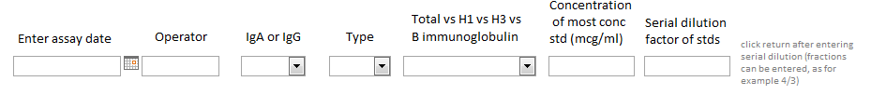

Fill the fields as required

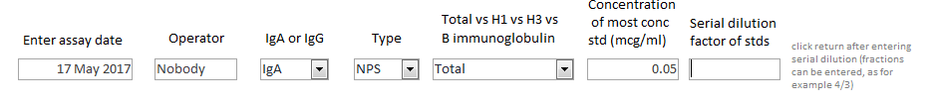

For the serial dilution factor field fractions can be entered such as 4/3, in addition to decimal formats. After entering the serial dilution click return.

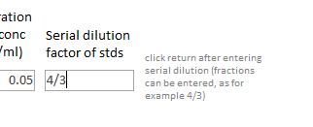

A graph of the standards will then appear:

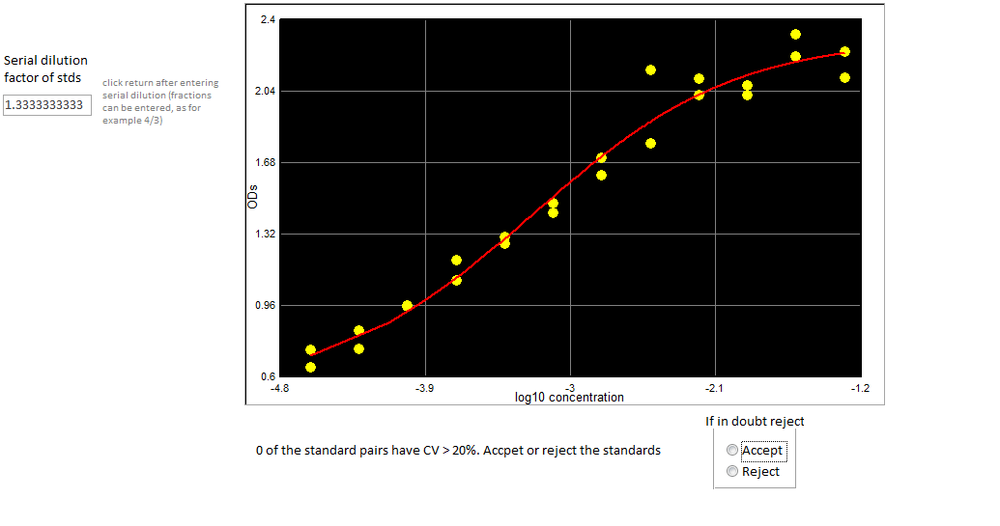

The number of standard pairs that violate a CV of 20% are given. Users can choose to Accept or Reject the plate at this stage. Note at any stage the whole process can be cancelled by clicking the cancel button at the left of the screen. Note if cancelled no data is saved – it cannot be recovered.

If reject is chosen the following button appears and only the file name and plate meta data is saved to the database.

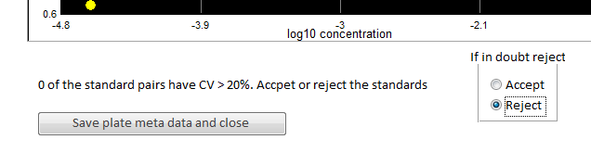

If Accept is chosen then the 96 well plate appears:

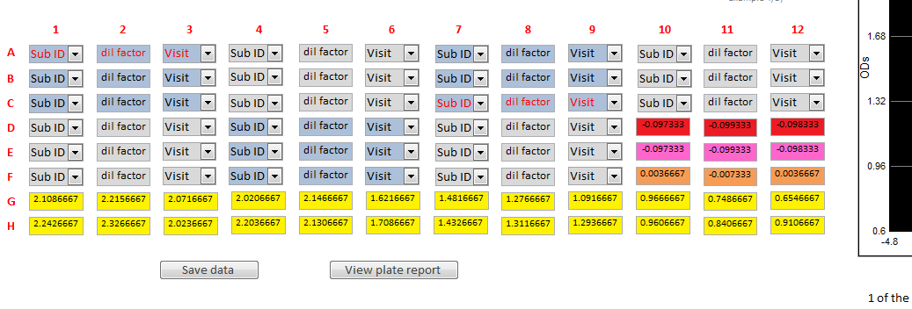

If the text is red then that subject passed the Quality Control, which is:

The ODs of all 3 wells or at least 1 pair

* Must have a CV <=20%
* The ODs must be in the range of the standard curve
* Lie within the linear part (see Appendix I for definition)

Double clicking on wells that passed QC, shows the OD and conc estimate on the standards curve in green.

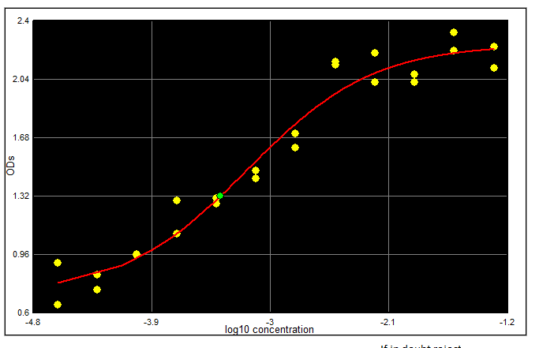

More detailed plate information can be viewed by clicking the plate report button. However before clicking the button all triplicate data must be filled in:

* Subject ID
* Dilution factor
* Visit #

For Subject ID, enter the first one or two digits and the scroll list will limit the entries

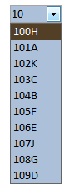

The data cannot be saved until all the triplicate data is entered.

After entering all the data (dummy data here):

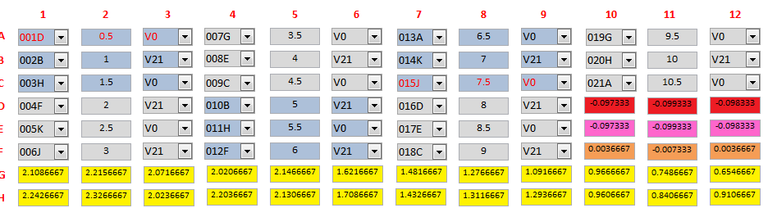

The view plate button can now be clicked, showing the following results for all the triplicate wells

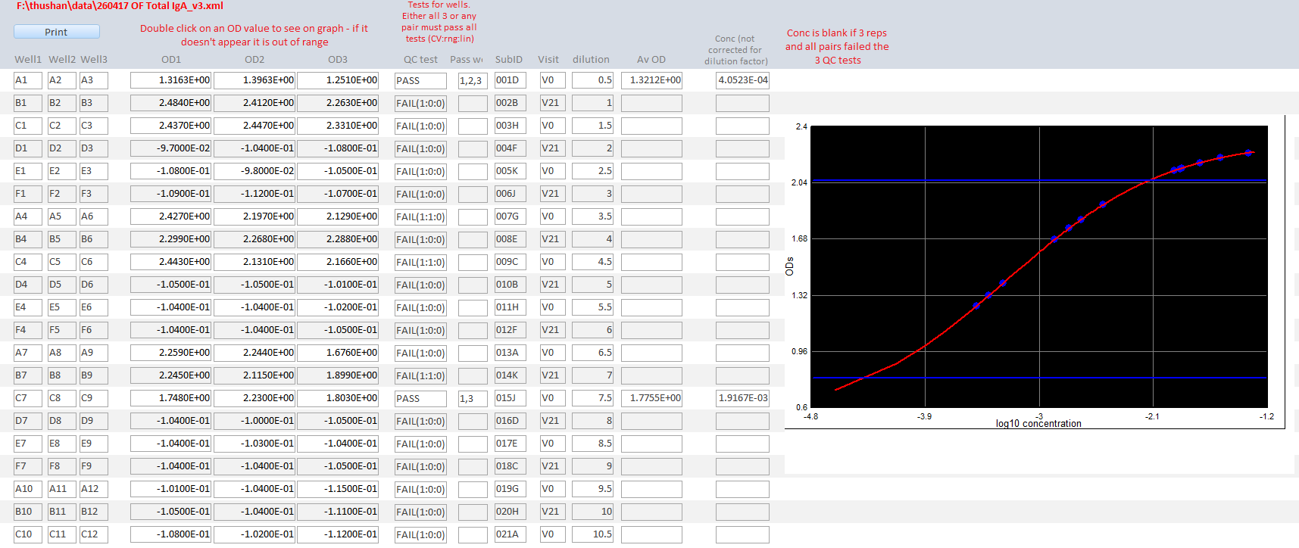

The horizontal lines show the linearity limit (see Appendix I).The QC test field shows whether a subject passed QC and the next field whether it was triplicate or duplicate wells. If a subject failed the test results of each QC test in the order of CV, range, linearity is given. 1 is pass, 0 is fail.

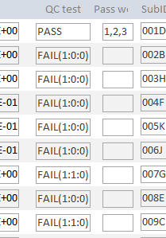

Double clicking on any of the OD wells or the Ave OD field

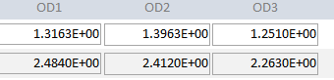

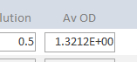

Shows the OD on the standards curve in green, for example for the Av OD above:

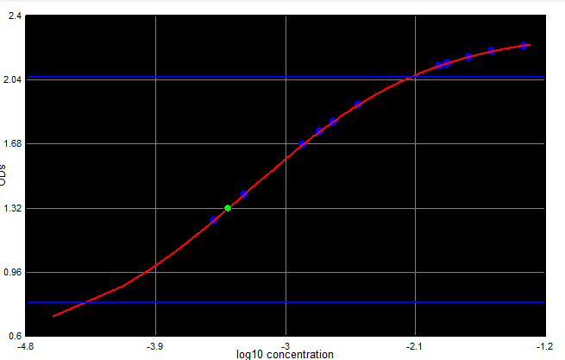

**If the dot does not appear it means that the OD is out of range.**

At any time the Print button can be pressed to get a screen dump of the relevant form.

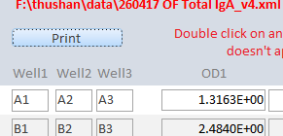

This automatically pastes a screen dump ready for printing in the windows print pictures tool.

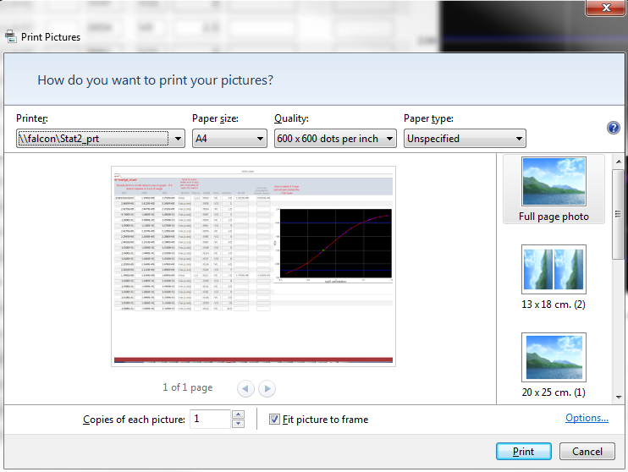

**Note uncheck the Fit picture to frame button to print all fields on a A4 side.**

Close the view plate report form by clicking in the top right corner.

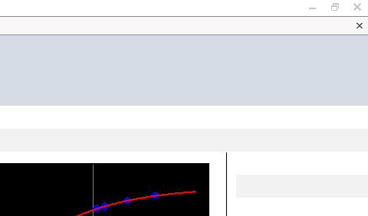

On the main form with the 96 well plate click on the button ‘Save data’ to import all entered data, the standards and the concentrations into the database.

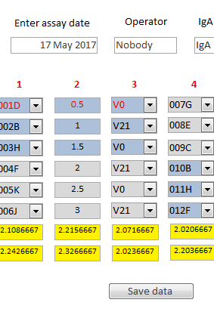

On successfully saving the data a message will appear

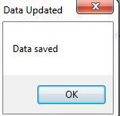

Click OK and in addition to saving the data this will clear the screen and prepare the database for further entry.

**Appendix I Definition of linearity**

The standard curve has known parametric form and is calculated at 10,000 points across the range of standard concentrations**.** The gradient of the standards curve is estimated at 10,000 points as:

(y(n) – y(n-1))/x(n) – x(n-1), where n = 2 to 10,000

The lower and upper limit for which this gradient is greater than or equal to 55% of the maximum gradient (which occurs at the midpoint) is then calculated as shown by the blue lines below.



Any ODS out of this range are ignored as the standards response is assumed not to be linear.

The 55% cut-off is a parameter in the model and can be changed.

**Appendix II Table design**

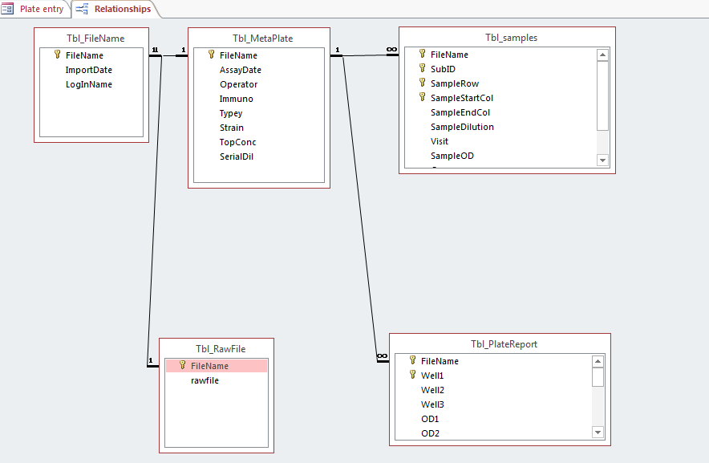

Tbl_Filename, Tbl_MetaPlate and Tbl_samples contain the file, plate and QC passed well concentrations.

Additional data is stored in:

Tbl_RawFile – This consists of a long text dump of the contents of the XML file, so files cannot be lost if their paths are moved or deleted.

Tbl_PlateReport – Contains details of the fit to the OD data for the wells.

All other tables are created on the fly and destroyed when the main form frm_entry is closed.

name_store is an internal table that is used to hold the last location for the file browser – do not delete

**Appendix III Standard curve fitting**

Four parameter logistic curves are fitted to the standards by default – this can easily be changed by editing a switch in the code.

The fit is performed by minimising the least square error, using unconstrained minimization via the Nelder Mead algorithm.

This is contained in the NelderMead module as:

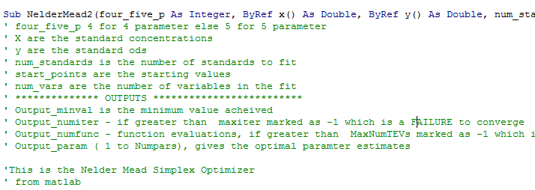

To improve validation this is identical to the matlab fmin function and test functions give identical results in matlab and VBA

**Appendix IV Forms**

There are three forms. The main form for controlling the application is frm_entry – all functionality is initiated form here. This is the only form that should be opened manually.

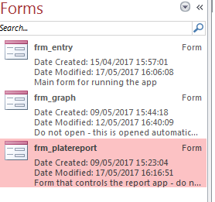

**Appendix V Modules**

**There are 16 Modules containing the VBA code, behind the application**

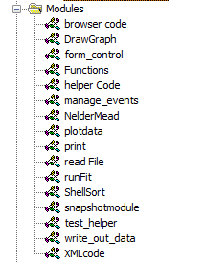

1. **Browser_code**

Code for the file browser functionality also includes file path functions

1. **DrawGraph**

Draws the figures using the active X control NTGraph (see Appendix Vi). Also extracts standards and the backgrounds (two forms)

1. **form_control**

Form controls for the 96 well plate, plus vis/invis controls

1. **Functions**

4 and 5 parameters logistic functions for the Nelder Mead optimization

1. **Helper_Code**

Utility functions

1. **Manage_events**

This was used in dynamic building of forms with many events – not needed for running

1. **NelederMead**

Optimisation functions, use validated Matlab routine nelderMEad2

1. **Plotdata**

Functions used to check and plot data on the report form

1. **Print**

API for printing file to windows print window – do not edit.

1. **readFile**

Functions for reading form csv file – not used

1. **runFit**

Used for testing and validating the NelderMead optimization

1. **ShellSort**

Very simple sort function – OK for this application as sorts are small

1. **Snapshotmodule**

Snapshot API – do not edit.

1. **test_helper**

Functions for filling forms and controlling ribbon and deleting data for testing. **DO NOT USE**

delete_data_from_tbl_filename as it deletes all the data.

1. **write_out_data**

Functions to write the final data to the tables – note the main form (frm_entry) is unbound, so all has to be done manually with these functions.

1. **XMLcode**

Function to extract XML data form XML data at node level

There is one class with timer used for debugging and code optimisation

**Appendix VI Code libraries**

There are two code libraries that need to be registered that are required by this code:

**NTGraph.ocx** This is an active control for plotting graphs (much more robust than invoking Excel).

<https://www.codeproject.com/Articles/3214/D-Graph-ActiveX-Control> (referenced 17 May 2017)

**clipboard.dll** Class library that gives methods to paste clipboard to windows print functions

<http://www.vbforums.com/showthread.php?585616-clipboard-activex-for-vba-vbs-etc> (referenced 17 May 2017)

These must be registered (see below – note this requires admin rights) on any machines that will run the application, even though the actual database will be at a network location.

regsvr32 NTGraph.ocx

regsvr32 clipboard.dll